ANNEXURE
APPLICATION-BASED QUESTIONS
Probability and Machine-Learning Model Evaluation

Name: | SHAIK THOUHID
Register Number: | 192421280
Department / Class: | IT
Course / Subject: | ITA0609-MACHINE LEARNING

Annexure A - Application-Based Questions
Question 1: Conditional Probability Using Bayes’ Theorem

A parking facility has three sections. Section A contains 5 red, 3 blue, and 2 black cars; Section B contains 4 red, 6 blue, and 5 black cars; and Section C contains 7 red, 2 blue, and 6 black cars. Section B is twice as likely to be selected as Sections A and C. Given that the selected car is blue, find the probability that it came from Section C.
Step 1: Organize the given information
Section | Red Cars | Blue Cars | Black Cars | Total Cars
A | 5 | 3 | 2 | 10
B | 4 | 6 | 5 | 15
C | 7 | 2 | 6 | 15
Table 1. Distribution of cars in the three parking sections
Step 2: Determine the probability of selecting each section
Let the selection weights of Sections A, B, and C be 1, 2, and 1 respectively. The total weight is 1 + 2 + 1 = 4.
P(A) = 1/4, P(B) = 2/4 = 1/2, P(C) = 1/4

Step 3: Find the probability of selecting a blue car from each section
P(Blue | A) = 3/10
P(Blue | B) = 6/15 = 2/5
P(Blue | C) = 2/15

Step 4: Find the total probability of selecting a blue car
P(Blue) = P(A)P(Blue | A) + P(B)P(Blue | B) + P(C)P(Blue | C)
= (1/4 × 3/10) + (1/2 × 2/5) + (1/4 × 2/15)
= 3/40 + 1/5 + 1/30 = 37/120

Step 5: Apply Bayes’ theorem
P(C | Blue) = [P(C) × P(Blue | C)] / P(Blue)
= [(1/4) × (2/15)] / (37/120)
= (1/30) × (120/37) = 4/37
P(C | Blue) ≈ 0.1081 = 10.81%

Final Answer: The probability that the blue car came from Section C is 4/37, or approximately 10.81%.
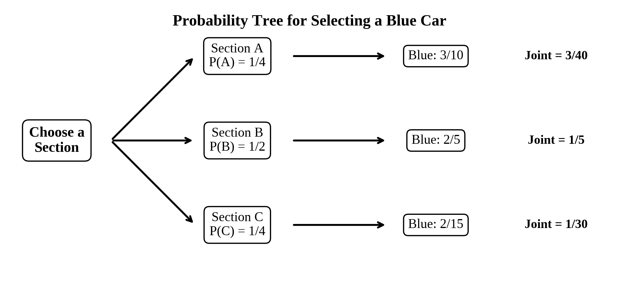
Figure 1. Weighted probability tree used in the Bayes’ theorem calculation

Question 2: Analysis of Training and Validation Loss

The model is evaluated using its training loss and validation loss over eight epochs. A good model should reduce both losses. Overfitting is indicated when training loss continues to decrease but validation loss begins to increase.
Epoch | Training Loss | Validation Loss | Observation
1 | 2.8 | 2.4 | Both losses decrease
2 | 2.5 | 2.2 | Both losses decrease
3 | 2.2 | 2.0 | Lowest validation loss
4 | 2.0 | 2.1 | Validation loss starts rising
5 | 1.8 | 2.3 | Gap becomes wider
6 | 1.6 | 2.6 | Clear overfitting
7 | 1.5 | 2.9 | Overfitting increases
8 | 1.3 | 3.2 | Severe overfitting
Table 2. Training and validation loss values across epochs
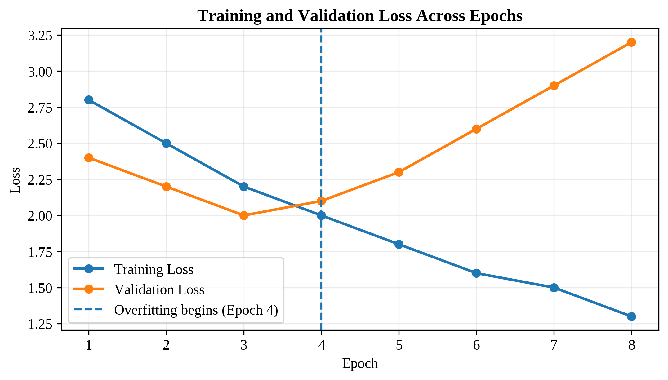
Figure 2. Validation loss reaches its minimum at Epoch 3 and rises from Epoch 4 onward
i) Epoch at which the model begins to overfit
The model begins to overfit at Epoch 4. Up to Epoch 3, both training and validation loss decrease. At Epoch 4, training loss falls from 2.2 to 2.0, while validation loss rises from 2.0 to 2.1. This opposite movement shows that the model is improving on the training data but becoming worse on unseen validation data.
The best checkpoint is therefore Epoch 3 because it has the minimum validation loss of 2.0.
ii) Two effective techniques to reduce overfitting
1. Early stopping: Monitor validation loss and stop training when it no longer improves. In this case, training should stop at or immediately after Epoch 3, and the weights from Epoch 3 should be restored.
2. Dropout regularization: Randomly deactivate a fraction of neurons during training. This prevents the model from depending too heavily on particular neurons and encourages it to learn more general patterns.
iii) Effect of overfitting on generalization
Overfitting reduces the model’s ability to generalize. The model begins to memorize specific patterns and noise in the training set rather than learning the underlying relationship. As a result, it produces very low training loss but higher loss and more errors on new, unseen data. Such a model may appear excellent during training but perform poorly in real-world use.
Conclusion: Use the Epoch 3 model and apply early stopping together with regularization to obtain better validation performance.

Question 3: Analysis of Training and Validation Accuracy

The model is evaluated using training and validation accuracy over eight epochs. Increasing training accuracy alone does not guarantee a good model. The validation accuracy must also remain stable or improve for the model to generalize well.
Epoch | Training Accuracy | Validation Accuracy | Observation
1 | 60% | 58% | Both accuracies improve
2 | 65% | 63% | Both accuracies improve
3 | 70% | 68% | Both accuracies improve
4 | 75% | 72% | Healthy learning
5 | 80% | 73% | Highest validation accuracy
6 | 85% | 72% | Validation accuracy declines
7 | 88% | 70% | Performance gap widens
8 | 92% | 68% | Severe overfitting
Table 3. Training and validation accuracy values across epochs
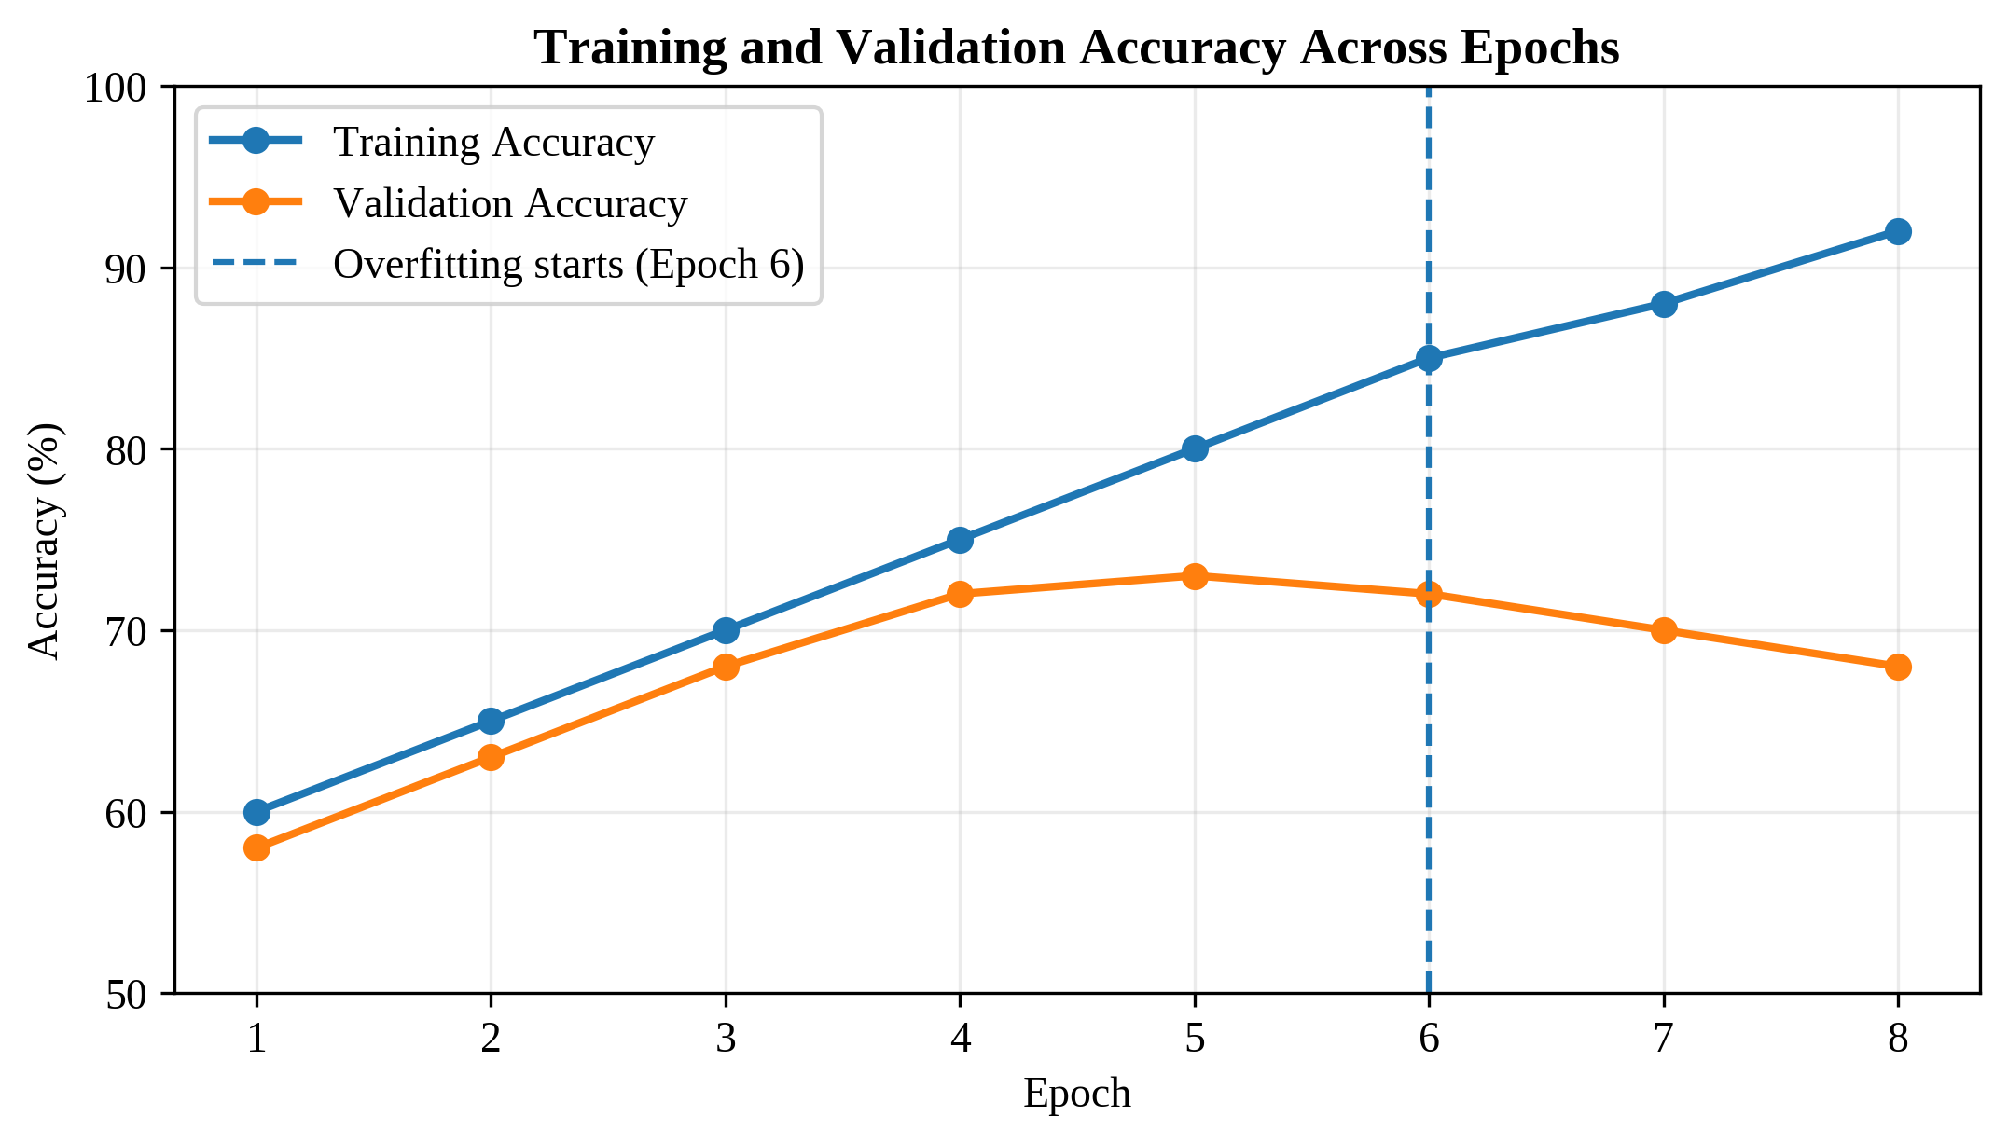
Figure 3. Validation accuracy peaks at Epoch 5 and begins declining at Epoch 6
i) Epoch at which the model starts overfitting
The model starts overfitting at Epoch 6. Validation accuracy reaches its highest value of 73% at Epoch 5. At Epoch 6, training accuracy increases from 80% to 85%, but validation accuracy decreases from 73% to 72%. The decline continues in later epochs, confirming overfitting.
The best checkpoint is Epoch 5 because it provides the highest validation accuracy.
ii) Why validation accuracy decreases while training accuracy increases
As training continues, the model fits the training examples more closely and may begin memorizing noise, rare cases, or dataset-specific details. This increases training accuracy. However, these memorized details are not useful for new data, so the model makes more mistakes on the validation set. The growing difference between training and validation accuracy is called the generalization gap.
iii) Two methods to improve validation performance
1. Data augmentation or additional training data: Create varied training examples, such as transformed images or slightly modified samples, or collect more representative data. This exposes the model to greater diversity and helps it learn patterns that transfer to unseen data.
2. Regularization with early stopping: Apply dropout or L2 weight penalties to restrict excessive model complexity, and stop training when validation accuracy stops improving. For this model, the weights from Epoch 5 should be retained.
Conclusion: The model should be selected at Epoch 5. Further training increases memorization and reduces its accuracy on unseen data.
Overall Summary
Question | Key Result | Recommended Decision
1 | P(Section C | Blue) = 4/37 ≈ 10.81% | Use weighted Bayes’ theorem
2 | Overfitting begins at Epoch 4 | Retain Epoch 3 model
3 | Overfitting begins at Epoch 6 | Retain Epoch 5 model

